SOFTWARE REQUIREMENTS SPECIFICATION

Dream More Hotel
Management System (DMHMS)
A centralized platform for room, reservation, guest, billing, and reporting management
GROUP MEMBERS

Heran Hailemariam Kahsay — AASTU (Group Leader)
Eman Mohammed Muzein — JMU
Bezawit Tsegaye Biresaw — BDU
Iman Ibrahim Omer — ASTU
Hanan Mohammed Wolie — AAU

Table of Contents
1. Introduction 3
1.1 Purpose 3
1.2 Scope 3
1.3 Definitions, Acronyms, and Abbreviations 3
1.4 References 3
1.5 Document Overview 4
2. Overall Description 5
2.1 Product Perspective 5
2.2 Product Functions 5
2.3 User Classes and Characteristics 5
2.4 Operating Environment 6
2.5 Design and Implementation Constraints 6
2.6 Assumptions and Dependencies 7
3. System Models 8
3.1 Use Case Diagram 8
3.2 Data Model (Entity-Relationship Diagram) 9
3.3 Room Status State Diagram 10
4. Functional Requirements 11
4.1 Room and Reservation Management 11
4.2 Food Ordering Management 13
4.3 Billing and Payment Management 14
4.4 Email Notification Management 18
4.5 Reporting Dashboard 19
5. Use Case Descriptions 21
6. Non-Functional Requirements 26
7. Supporting Specifications 28

1. Introduction

1.1 Purpose
The hospitality industry depends on accurate records and fast, reliable service, yet many hotels still rely on manual, paper-based processes to manage reservations, guest information, and billing. These methods are slow, error-prone, and difficult to scale as guest volumes grow.
The Dream More Hotel Management System (DMHMS) replaces these manual processes with a centralized, computerized platform. It allows hotel staff to manage room inventory, guest registration, reservations, check-in and check-out, billing, and reporting from a single, consistent system — reducing administrative workload, improving data accuracy, and giving management real-time visibility into hotel performance.
This Software Requirements Specification (SRS) defines the functional and non-functional requirements of DMHMS. It is intended for developers, testers, project supervisors, and other stakeholders who need a shared, unambiguous understanding of what the system must do.

1.2 Scope
DMHMS covers the core day-to-day operations of Dream More Hotel: room management, customer management, reservation handling, check-in/check-out, billing and payment processing, and operational reporting. Authorized staff manage these functions directly, while customers may submit reservation requests and view their own booking details.
The system is a web-based application accessible from desktop, tablet, and mobile browsers, backed by a PostgreSQL database. Its scope is intentionally limited to internal hotel operations — it does not integrate with external services such as flight or transport booking, food delivery platforms, or third-party travel agencies.

1.3 Definitions, Acronyms, and Abbreviations
Term / Acronym | Definition
DMHMS | Dream More Hotel Management System
SRS | Software Requirements Specification — this document
Admin | System administrator responsible for user accounts and system configuration
Customer | A guest who books or stays at the hotel
Reservation | The act of booking a room for a specific date range
Check-in | The process of registering an arriving guest into the system
Check-out | The process of completing and closing out a guest's stay
FR | Functional Requirement
ERD | Entity-Relationship Diagram
UC | Use Case

1.4 References
- IEEE Std 830-1998 — Recommended Practice for Software Requirements Specifications
- Dream More Hotel operational process documentation
- Project proposal and system feasibility study, Dream More Hotel

1.5 Document Overview
Section 2 describes the system at a high level — its perspective, functions, user classes, and operating environment. Section 3 presents the system models: use case, data, and state diagrams. Section 4 details the functional requirements, organized by module. Section 5 walks through the primary use cases end to end. Section 6 defines non-functional requirements such as performance and security, and Section 7 covers supporting specifications, including data rules and interface requirements.

2. Overall Description

2.1 Product Perspective
DMHMS is a standalone, web-based application built on a three-tier architecture: a browser-based client, a Node.js/Express application server, and a PostgreSQL database. It is designed specifically for Dream More Hotel and is not part of a larger product family, though it is structured to allow future integration with additional modules.
The system centralizes all operational data — customer records, room information, reservations, food orders, and payment transactions — behind a single application layer, so that every authorized user sees consistent, up-to-date information regardless of which device or workstation they use. The application layer also integrates with three external services: the Chapa payment gateway for processing guest payments, an email/SMTP service for automated booking and payment notifications, and the Google Gemini API for AI-generated analytical insights on the reporting dashboard.
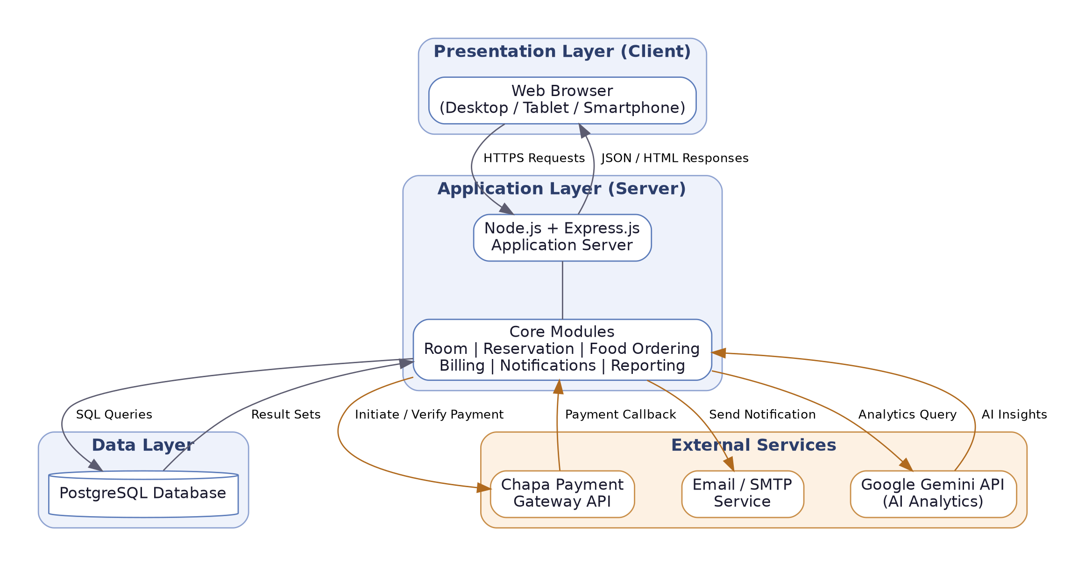
Figure 2.1 — System Architecture (Three-Tier, with External Service Integrations)

2.2 Product Functions
The system's functionality is organized into seven modules:
- Room Management — create, update, and deactivate room records; track type, price, and status.
- Customer Management — register guests, maintain profiles, and view booking history.
- Reservation Management — create, modify, and cancel bookings with automatic availability checks.
- Check-in / Check-out Management — register arrivals, assign rooms, and close out departures.
- Food Ordering Management — browse the menu, place food orders, and settle food bills.
- Billing and Payment Management — generate invoices, process payments through the Chapa gateway, and issue receipts.
- Notification Management — send automated email confirmations for bookings, cancellations, and payments.
- Report Generation — produce occupancy, revenue, food sales, and customer reports, enhanced with AI-generated insights via the Gemini API.

2.3 User Classes and Characteristics
User Class | Description | Technical Skill
Administrator | Full system access; manages user accounts, configuration, and all reports. | Comfortable with system administration
Manager | Views reports, monitors occupancy, and reviews financial activity to guide decisions. | Familiar with hotel management practices
Receptionist | Primary daily user; handles guests, reservations, check-in/out, and billing. | Basic computer literacy
Customer | Makes reservations and views booking details through the guest-facing interface. | Basic web familiarity

2.4 Operating Environment

Hardware Requirements
- Desktop, laptop, tablet, or smartphone with a minimum of 4 GB RAM
- Stable internet connection
- Server capable of hosting the application and database

Software Requirements
Category | Technology
Operating Systems | Windows, Linux, or macOS
Web Browsers | Chrome, Firefox, Edge, or Safari
Backend | Node.js and Express.js
Database | PostgreSQL
Payment Gateway | Chapa API (initialize, verify, and webhook callback)
AI Service | Google Gemini API (dashboard analytics and insights)
Email Service | SMTP-based transactional email service
Version Control | Git and GitHub

2.5 Design and Implementation Constraints
Category | Constraint
Technical | Must run on modern web browsers and integrate with a PostgreSQL database.
Security | Customer and payment data must be protected; access restricted by role.
Time | Development must follow the academic semester project schedule.
Resource | Limited to available hardware, software, and an academic project budget.
Usability | Interface must remain simple enough for users with basic computer skills.

2.6 Assumptions and Dependencies

Assumptions
- Hotel staff have basic computer literacy and can operate web applications.
- Users provide accurate information during registration and reservation.
- The hotel has access to reliable internet connectivity.
- Authorized users follow system policies and procedures.

Dependencies
- A functioning PostgreSQL database for data storage and retrieval.
- Standard web browsers for user access.
- Continuous power and internet service for uninterrupted operation.
- Correct functioning of server hardware and software components.
- Availability of the Chapa payment gateway for processing guest payments.
- Availability of the Google Gemini API for AI-generated dashboard insights.
- A functioning email/SMTP service for delivering booking and payment notifications.

3. System Models
This section presents the key models used to design DMHMS: the use case diagram showing how each actor interacts with the system, the entity-relationship diagram showing how data is structured, and the state diagram showing how a room's status changes over its lifecycle.

3.1 Use Case Diagram
The diagram below summarizes the primary interactions between the four actors — Administrator, Manager, Receptionist, and Customer — and the core use cases they perform, including food ordering, Chapa-based payment, email notifications, and AI-generated insights.
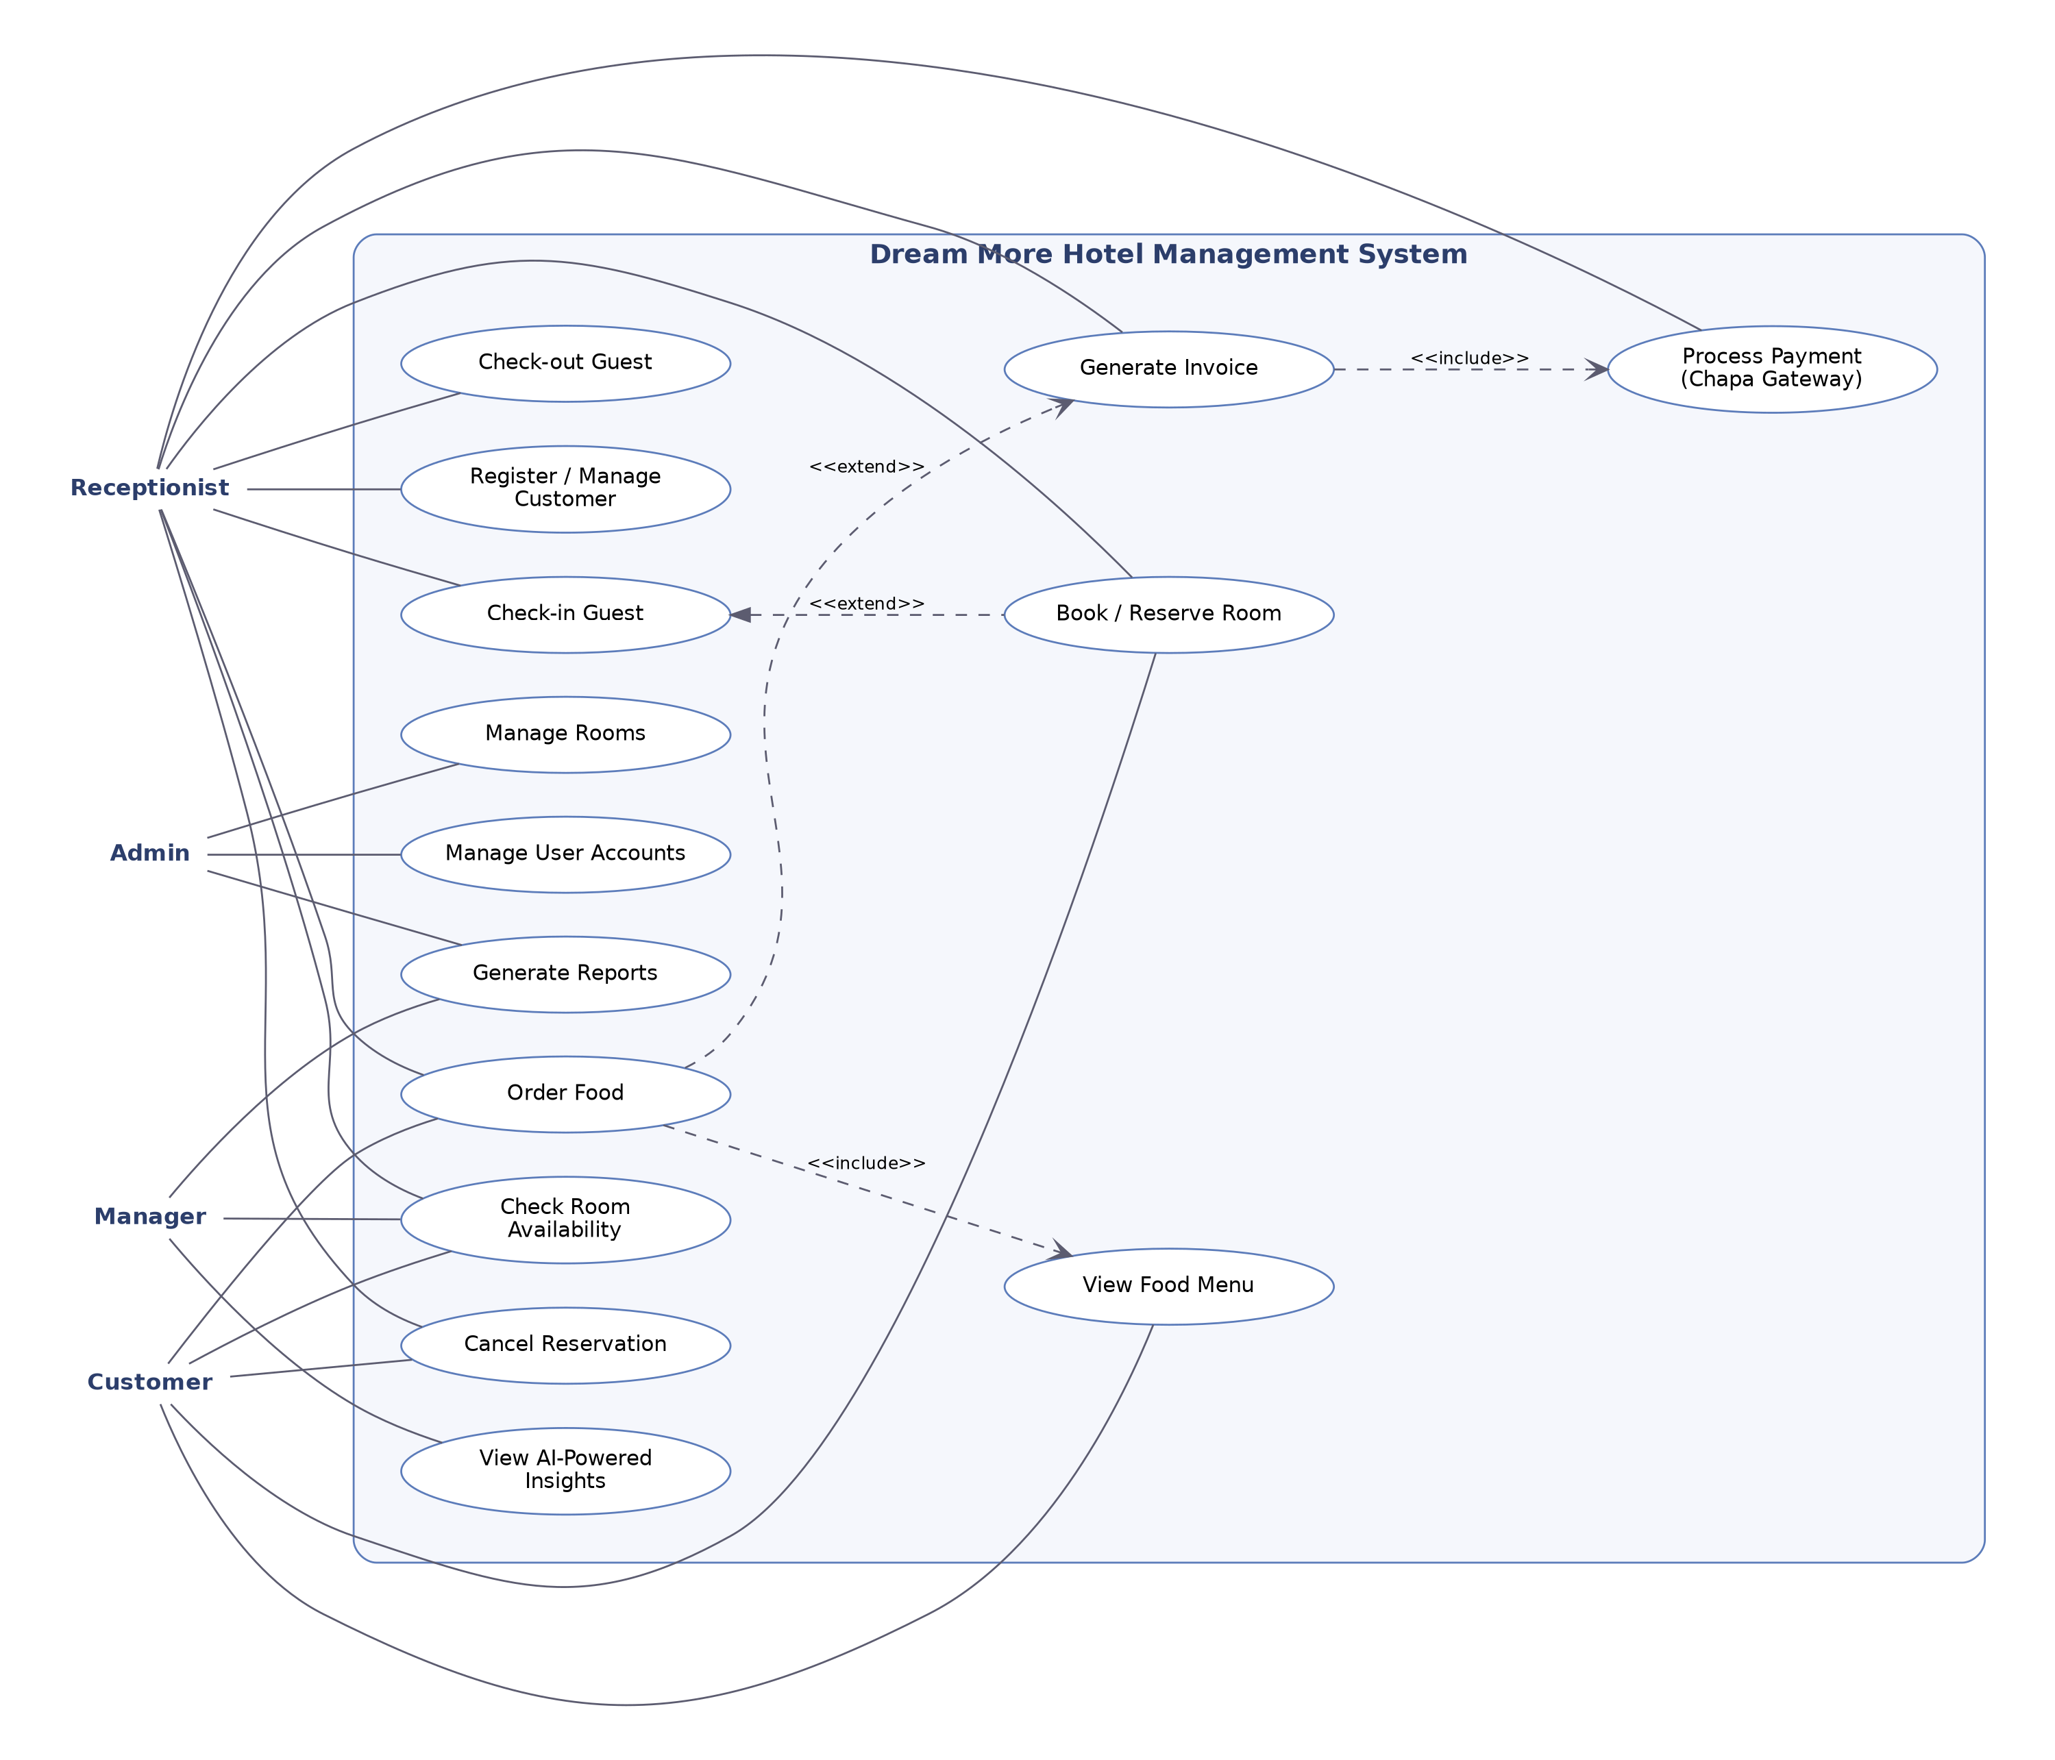
Figure 3.1 — System Use Case Diagram

3.2 Data Model (Entity-Relationship Diagram)
The data model below shows the main entities managed by DMHMS and the relationships between them. A Customer may have many Reservations and Food Orders; each Reservation is linked to one Room and produces one Invoice; each Food Order references a Menu Item and is billed through an Invoice; each Invoice may be settled through one or more Payments, which store the Chapa transaction reference; and System Users create and manage Reservations on behalf of guests.
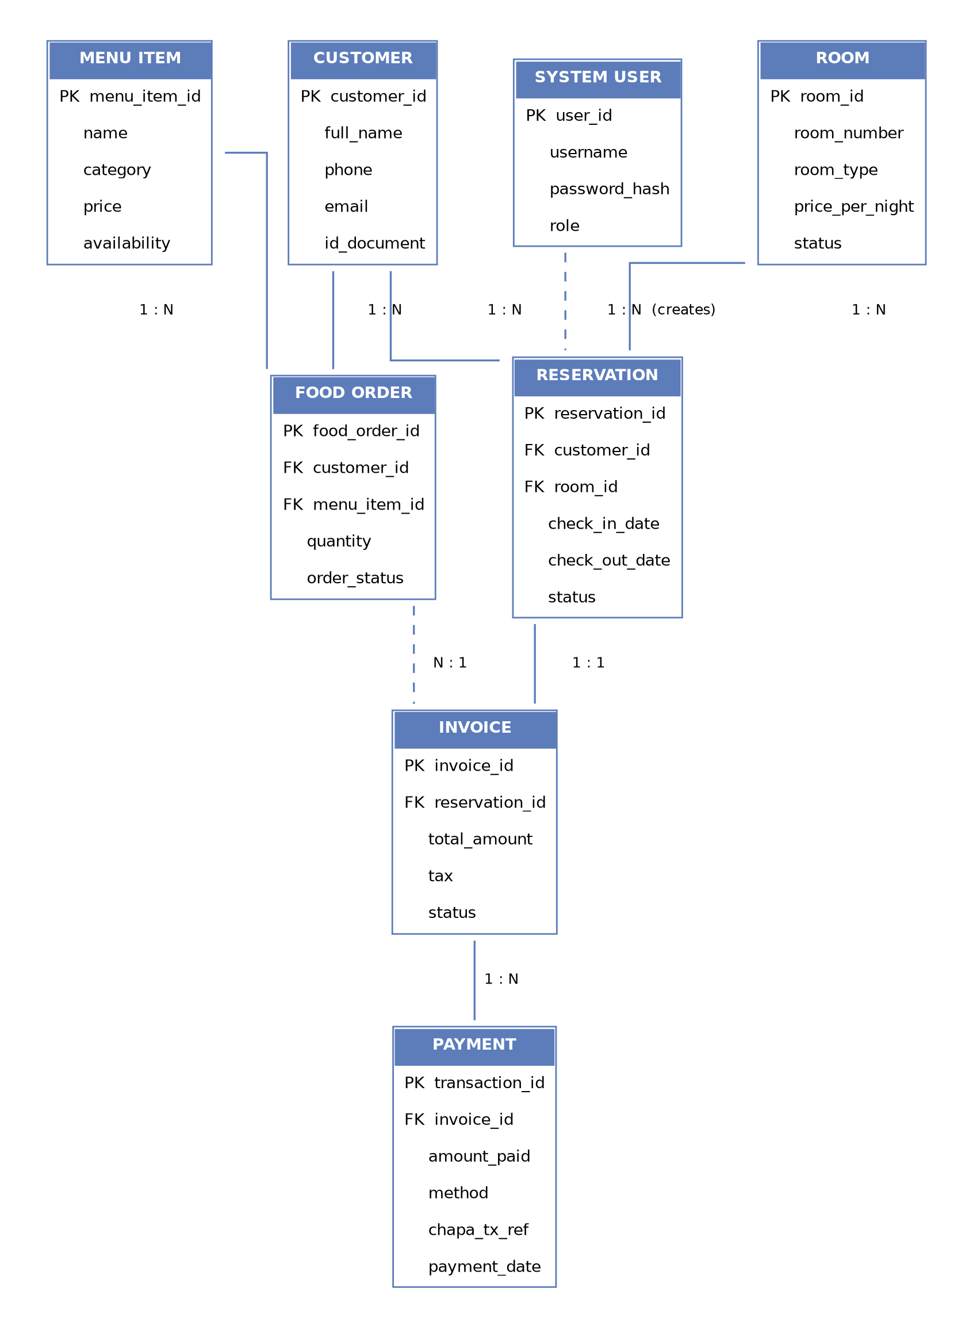
Figure 3.2 — Entity-Relationship Diagram

3.3 Room Status State Diagram
A room progresses through a defined set of states during its operational lifecycle. This diagram governs the room status transitions enforced by the Room and Reservation Management module (see Section 4.1.2).
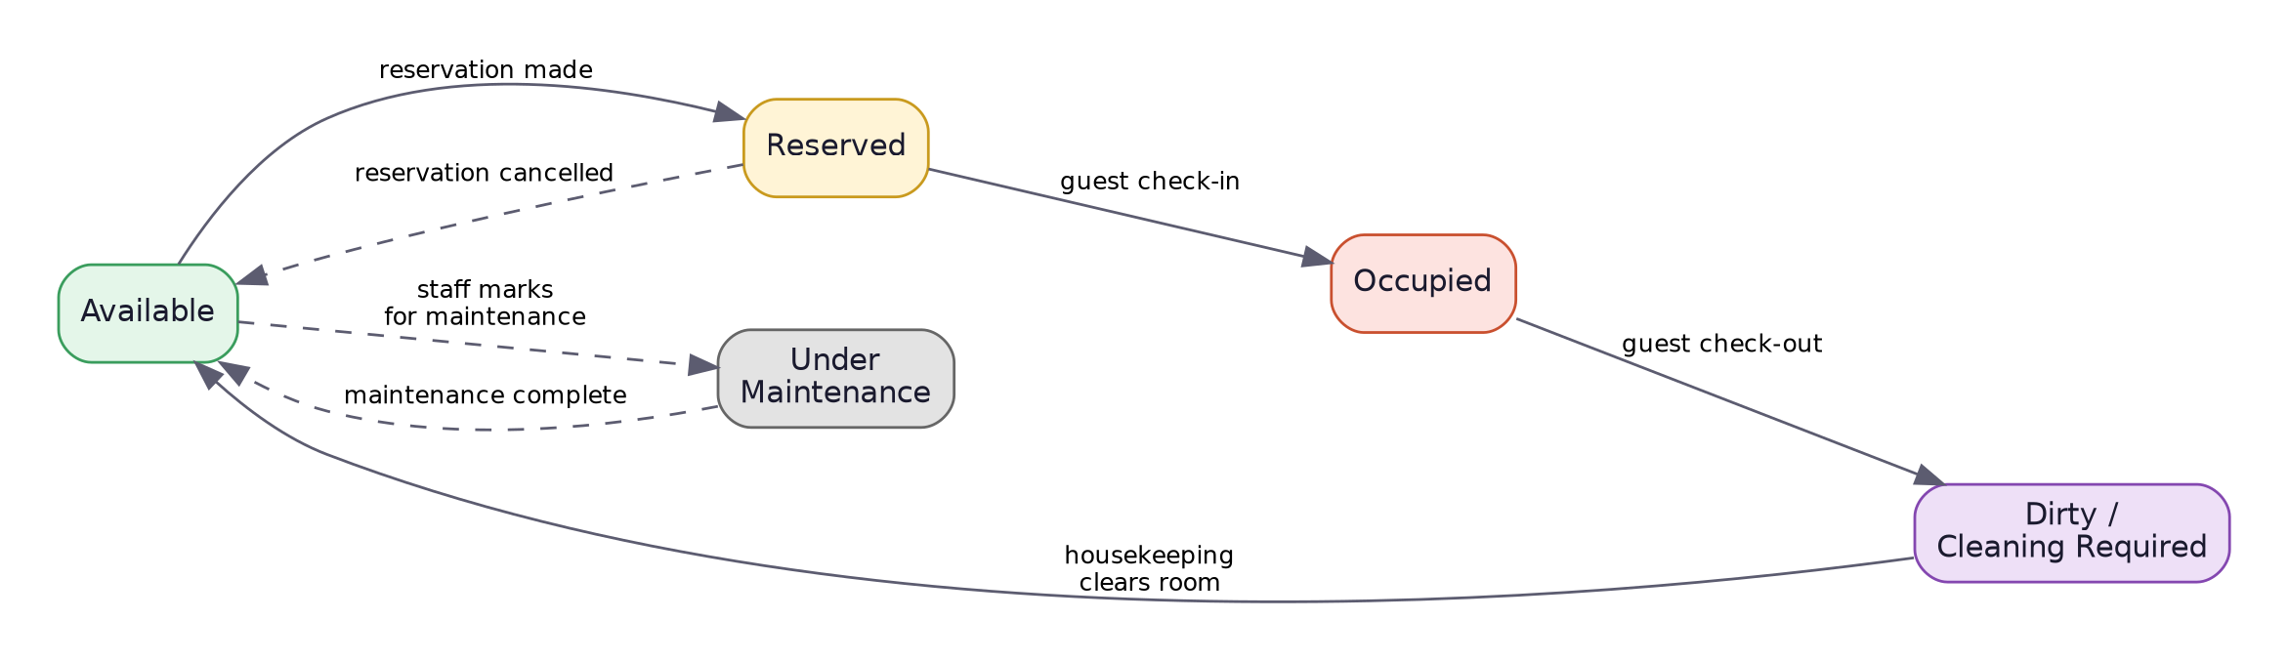
Figure 3.3 — Room Status State Diagram

4. Functional Requirements
This section defines the detailed functional requirements of DMHMS, grouped by module. Each requirement is uniquely identified and assigned a priority (High / Medium / Low) reflecting its importance to core hotel operations.

4.1 Room and Reservation Management
This module controls hotel room inventory, tracks live occupancy states, and prevents conflicting room bookings. It integrates with Customer Management to verify guest check-in status and feeds directly into Billing and Payment Management for charge calculation.

4.1.1 Room Management
Allows authorized staff to create, modify, and retire room records, with validation to preserve data consistency.
ID | Requirement | Priority
FR-4.1.1.1 | The system shall allow administrators to create a new room record with Room Number, Room Type, Base Price per Night, and Initial Status. | High
FR-4.1.1.2 | The system shall reject creation of a room whose Room Number already exists, raising a “Duplicate Room Identifier” error. | High
FR-4.1.1.3 | The system shall require Room Price to be a positive number greater than zero. | High
FR-4.1.1.4 | The system shall allow authorized staff to update existing room records, including pricing and type. | High
FR-4.1.1.5 | The system shall prevent deletion of a room whose status is “Occupied” or “Reserved.” | High
FR-4.1.1.6 | The system shall remove rooms via a soft-delete (archival flag) rather than a hard delete, to preserve historical reporting data. | Medium
FR-4.1.1.7 | The system shall require a confirmation prompt before committing any room modification or deletion. | High

4.1.2 Room Status Management
Tracks and synchronizes room availability in real time across staff and guest-facing interfaces (see Figure 3.3).
ID | Requirement | Priority
FR-4.1.2.1 | The system shall maintain five room states: Available, Occupied, Reserved, Under Maintenance, and Dirty/Cleaning Required. | High
FR-4.1.2.2 | The system shall transition a room from Reserved to Occupied automatically upon guest check-in. | High
FR-4.1.2.3 | The system shall transition a room from Occupied to Dirty/Cleaning Required automatically upon guest check-out. | High
FR-4.1.2.4 | The system shall allow housekeeping staff to manually change a room from Dirty/Cleaning Required to Available. | Medium
FR-4.1.2.5 | The system shall allow maintenance staff to override an Available room to Under Maintenance, removing it from guest-facing search results. | High

4.1.3 Reservation Management
Coordinates guest reservations, validating requested dates against real-time room availability.
ID | Requirement | Priority
FR-4.1.3.1 | The system shall allow guests and front-desk staff to enter Check-in and Check-out dates and room preferences. | High
FR-4.1.3.2 | The system shall require Check-in Date ≥ current date, and Check-out Date at least 1 day after Check-in Date. | High
FR-4.1.3.3 | The system shall calculate total booking cost before submission, including room rate, duration, and applicable taxes. | High
FR-4.1.3.4 | The system shall generate a unique Reservation ID in the format RES-YYYYMMDD-XXXXX upon confirmed booking. | High
FR-4.1.3.5 | The system shall allow reservation modifications (dates or room) up to 24 hours before the original check-in time. | Medium
FR-4.1.3.6 | The system shall re-validate room availability for any modified reservation before finalizing the change. | High
FR-4.1.3.7 | The system shall support reservation cancellation, setting the record to Cancelled and the room back to Available. | High

4.1.4 Availability and Double-Booking Prevention
Enforces transactional safeguards to prevent two guests from being assigned the same room for overlapping dates.
ID | Requirement | Priority
FR-4.1.4.1 | The system shall filter out rooms with overlapping reservations for the requested date range during availability search. | High
FR-4.1.4.2 | The system shall apply database transaction locking during booking submission so that only one of two simultaneous requests for the same room succeeds. | High
FR-4.1.4.3 | The system shall roll back a losing concurrent booking transaction and display “Room unavailable for the selected dates.” | High

4.2 Food Ordering Management
This module allows guests to browse the restaurant menu, place food orders, and settle food bills either independently or together with their room invoice. It integrates with Customer Management to link orders to a guest profile, and with Billing and Payment Management so that food charges can be combined into a single invoice.

4.2.1 Menu Management
ID | Requirement | Priority
FR-4.2.1.1 | The system shall allow authorized staff to create, update, and deactivate menu items, including name, category, price, description, and availability. | High
FR-4.2.1.2 | The system shall allow guests and staff to view the menu, filterable by category (e.g., breakfast, main course, beverages). | High
FR-4.2.1.3 | The system shall hide unavailable or deactivated items from the guest-facing menu view. | Medium
FR-4.2.1.4 | The system shall require menu item prices to be positive values greater than zero. | High

4.2.2 Food Ordering
ID | Requirement | Priority
FR-4.2.2.1 | The system shall allow a logged-in guest or receptionist to place a food order by selecting menu items and quantities. | High
FR-4.2.2.2 | The system shall associate each food order with a customer and, where applicable, an active reservation or room number. | High
FR-4.2.2.3 | The system shall calculate the order subtotal automatically as items are added or removed. | High
FR-4.2.2.4 | The system shall generate a unique Order ID for each food order. | High
FR-4.2.2.5 | The system shall allow a guest or staff member to modify or cancel a food order before it is marked as prepared. | Medium
FR-4.2.2.6 | The system shall track food order status (Received, Preparing, Delivered, Cancelled). | Medium
FR-4.2.2.7 | The system shall notify kitchen or restaurant staff of new incoming orders. | Medium

4.2.3 Food Order Billing
ID | Requirement | Priority
FR-4.2.3.1 | The system shall allow a guest to pay for a food order independently or add it to their existing room invoice. | High
FR-4.2.3.2 | The system shall include all delivered food order charges when generating a guest's final invoice (see FR-4.3.1.4). | High
FR-4.2.3.3 | The system shall prevent billing for food orders that are still in “Received” or “Preparing” status. | Medium
FR-4.2.3.4 | The system shall allow a guest to pay for a standalone food order using the Chapa payment gateway (see Section 4.3.5). | High

4.3 Billing and Payment Management
This module manages all financial transactions, integrating with Reservation Management and Food Ordering Management to calculate guest charges. It generates invoices, processes payments through the Chapa payment gateway, tracks payment history, and issues receipts.

4.3.1 Invoice Generation
ID | Requirement | Priority
FR-4.3.1.1 | The system shall generate a unique invoice number for each transaction. | High
FR-4.3.1.2 | The system shall retrieve guest and reservation details from the Reservation and Customer modules. | High
FR-4.3.1.3 | The system shall calculate room charges based on room type, rate, and length of stay. | High
FR-4.3.1.4 | The system shall retrieve and calculate all delivered food order charges linked to the guest. | Medium
FR-4.3.1.5 | The system shall calculate taxes, discounts, and the total payable amount automatically. | High
FR-4.3.1.6 | The system shall generate a complete itemized invoice including all room and food charges. | High
FR-4.3.1.7 | The system shall store each invoice with a timestamp and the responsible staff member. | Medium
FR-4.3.1.8 | The system shall display an error message if guest or reservation information cannot be retrieved. | Medium
FR-4.3.1.9 | The system shall prevent invoice generation if required billing information is incomplete. | High

4.3.2 Payment Processing
ID | Requirement | Priority
FR-4.3.2.1 | The system shall allow payment processing only against valid, existing invoices. | High
FR-4.3.2.2 | The system shall display the total payable and remaining balance before confirming payment. | High
FR-4.3.2.3 | The system shall support cash, card, mobile payment, and bank transfer methods, with card, mobile money, and bank transfer routed through the Chapa gateway. | High
FR-4.3.2.4 | The system shall support both full and partial payments. | High
FR-4.3.2.5 | The system shall recalculate and update the remaining balance automatically after each payment. | High
FR-4.3.2.6 | The system shall validate payment details and reject invalid or duplicate payments. | High
FR-4.3.2.7 | The system shall assign a unique transaction ID to each payment. | High
FR-4.3.2.8 | The system shall record amount, method, date, and staff for every payment. | High
FR-4.3.2.9 | The system shall update invoice status to Paid or Partially Paid accordingly. | High
FR-4.3.2.10 | The system shall trigger receipt generation immediately after a successful payment. | High
FR-4.3.2.11 | The system shall synchronize payment data with financial reports and dashboards. | Medium
FR-4.3.2.12 | The system shall display an error message if a payment transaction fails or is cancelled. | Medium
FR-4.3.2.13 | The system shall reject payment amounts that are invalid or exceed the outstanding balance. | High

4.3.3 Payment Tracking
ID | Requirement | Priority
FR-4.3.3.1 | The system shall permanently store all payment transactions linked to invoice and guest records. | High
FR-4.3.3.2 | The system shall display payment status (Paid, Partially Paid, Unpaid) for each invoice. | High
FR-4.3.3.3 | The system shall support searching payment records by invoice ID, transaction ID, or guest. | Medium
FR-4.3.3.4 | The system shall allow filtering of payment records by date, method, or status. | Medium
FR-4.3.3.5 | The system shall display the complete payment history for each guest. | Medium
FR-4.3.3.6 | The system shall log all payment adjustments, refunds, and modifications as audit entries. | High
FR-4.3.3.7 | The system shall prevent unauthorized modification or deletion of payment records. | High

4.3.4 Receipt Generation
ID | Requirement | Priority
FR-4.3.4.1 | The system shall automatically generate a receipt after successful payment. | High
FR-4.3.4.2 | The system shall generate a unique receipt number linked to the payment transaction. | High
FR-4.3.4.3 | The system shall include invoice details, guest information, and payment summary on the receipt. | High
FR-4.3.4.4 | The system shall allow printing, reprinting, and PDF export of receipts. | Medium
FR-4.3.4.5 | The system shall prevent modification of a receipt after it has been generated. | High
FR-4.3.4.6 | The system shall prevent receipt generation if the related payment was not completed successfully. | High

4.3.5 Chapa Payment Gateway Integration
Card, mobile money, and bank transfer payments are processed through Chapa, a licensed Ethiopian payment aggregator. DMHMS integrates with Chapa's REST API to initialize transactions, redirect guests to a secure hosted checkout, and verify payment outcomes via webhook callback, so that no card or account credentials are ever handled directly by DMHMS.
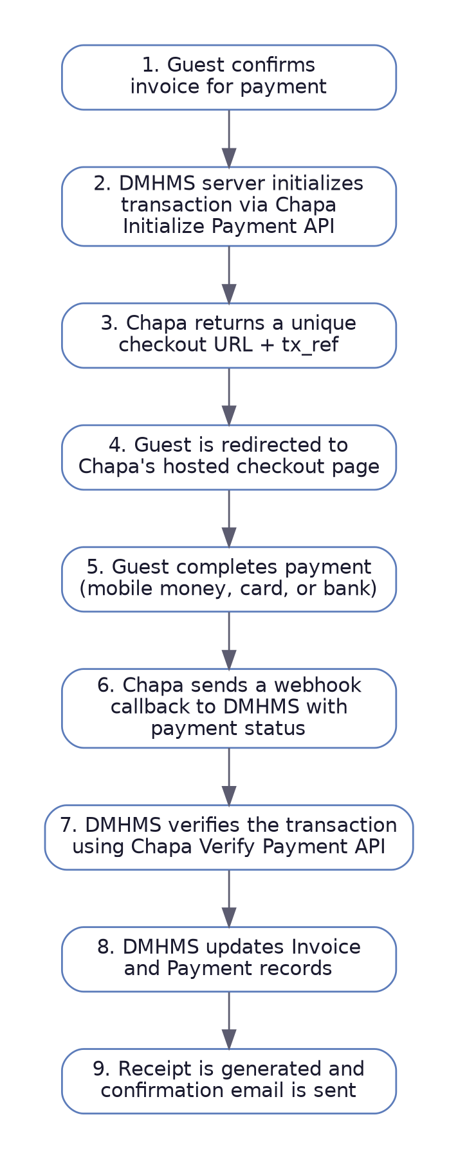
Figure 4.1 — Chapa Payment Integration Flow
ID | Requirement | Priority
FR-4.3.5.1 | The system shall initialize a Chapa transaction by calling the Chapa Initialize Payment endpoint with the invoice amount, currency (ETB), guest email, and a unique transaction reference (tx_ref). | High
FR-4.3.5.2 | The system shall store the generated tx_ref against the corresponding invoice before redirecting the guest. | High
FR-4.3.5.3 | The system shall redirect the guest to the checkout URL returned by Chapa to complete payment on Chapa's hosted page. | High
FR-4.3.5.4 | The system shall expose a webhook endpoint to receive asynchronous payment status callbacks from Chapa. | High
FR-4.3.5.5 | The system shall verify every incoming webhook by calling the Chapa Verify Payment endpoint before trusting its result, rather than relying solely on the callback payload. | High
FR-4.3.5.6 | The system shall update the invoice and payment record to Paid only after a successful verification response from Chapa. | High
FR-4.3.5.7 | The system shall mark the payment as Failed and notify the guest if Chapa reports a failed or cancelled transaction. | High
FR-4.3.5.8 | The system shall store the Chapa secret key and API credentials only on the server side and never expose them to the client. | High
FR-4.3.5.9 | The system shall use HTTPS for all communication with the Chapa API. | High
FR-4.3.5.10 | The system shall handle duplicate webhook callbacks idempotently, ensuring a transaction is not recorded as paid more than once. | High
FR-4.3.5.11 | The system shall display a clear confirmation screen to the guest after returning from the Chapa checkout page, reflecting the final verified payment status. | Medium
FR-4.3.5.12 | The system shall log all Chapa API requests and responses (excluding sensitive credentials) for troubleshooting and audit purposes. | Medium

4.4 Email Notification Management
This module sends automated email notifications to guests at key points in the reservation and payment lifecycle, keeping guests informed without requiring staff to contact them manually.

4.4.1 Booking Notifications
ID | Requirement | Priority
FR-4.4.1.1 | The system shall send a booking confirmation email to the guest's registered email address immediately after a reservation is successfully created. | High
FR-4.4.1.2 | The booking confirmation email shall include the Reservation ID, room type, check-in/check-out dates, and total estimated cost. | High
FR-4.4.1.3 | The system shall send a cancellation email to the guest when a reservation is cancelled. | High
FR-4.4.1.4 | The system shall send a modification email to the guest when reservation dates or room details are changed. | Medium
FR-4.4.1.5 | The system shall retry sending a notification email up to three times if initial delivery fails, and log the failure if all attempts are unsuccessful. | Medium

4.4.2 Payment and Receipt Notifications
ID | Requirement | Priority
FR-4.4.2.1 | The system shall send an email notification to the guest confirming successful payment, including the amount paid and remaining balance, if any. | High
FR-4.4.2.2 | The system shall attach or link the generated receipt (see FR-4.3.4.1) within the payment confirmation email. | Medium
FR-4.4.2.3 | The system shall notify the guest by email if a Chapa payment attempt fails or is cancelled. | Medium

4.5 Reporting Dashboard
The Reporting Dashboard provides management with summarized operational and financial information, drawing on data from reservations, food orders, billing, and customer records to support decision-making. It is further enhanced with AI-generated insights powered by the Google Gemini API.

4.5.1 Occupancy Reports
ID | Requirement | Priority
FR-4.5.1.1 | The system shall generate occupancy reports from room reservation data. | High
FR-4.5.1.2 | The system shall display total, occupied, available, reserved, and maintenance room counts. | High
FR-4.5.1.3 | The system shall calculate and display the room occupancy rate. | High
FR-4.5.1.4 | The system shall generate occupancy reports for daily, weekly, monthly, and yearly periods. | Medium
FR-4.5.1.5 | The system shall allow filtering and exporting of occupancy reports. | Medium

4.5.2 Revenue Reports
ID | Requirement | Priority
FR-4.5.2.1 | The system shall generate revenue reports from billing and payment data. | High
FR-4.5.2.2 | The system shall display total revenue by room reservations and food orders. | High
FR-4.5.2.3 | The system shall calculate total hotel revenue for a selected period. | High
FR-4.5.2.4 | The system shall generate daily, weekly, monthly, and yearly revenue reports. | Medium
FR-4.5.2.5 | The system shall allow filtering and exporting of revenue reports as PDF or Excel. | Medium

4.5.3 Customer Reports
ID | Requirement | Priority
FR-4.5.3.1 | The system shall generate customer reports from customer, reservation, and payment data. | Medium
FR-4.5.3.2 | The system shall display total registered, new, and returning customer counts. | Medium
FR-4.5.3.3 | The system shall display each customer's reservation and payment history. | Medium
FR-4.5.3.4 | The system shall identify top-spending customers. | Low
FR-4.5.3.5 | The system shall generate reports for daily, weekly, monthly, or custom date ranges. | Medium

4.5.4 Food Sales Reports
ID | Requirement | Priority
FR-4.5.4.1 | The system shall generate food sales reports using food order data. | Low
FR-4.5.4.2 | The system shall display total food orders and total restaurant revenue. | Low
FR-4.5.4.3 | The system shall identify best-selling and least-selling menu items. | Low
FR-4.5.4.4 | The system shall generate daily, weekly, and monthly food sales reports. | Low

4.5.5 AI-Powered Insights (Gemini Integration)
The Reporting Dashboard shall integrate with the Google Gemini API to generate natural-language summaries and analytical insights from occupancy, revenue, and customer data, helping managers interpret trends without manually analyzing raw figures.
ID | Requirement | Priority
FR-4.5.5.1 | The system shall send aggregated, anonymized occupancy, revenue, and food sales data to the Gemini API to generate a plain-language performance summary for a selected period. | Medium
FR-4.5.5.2 | The system shall allow a manager to ask follow-up questions about the displayed report in natural language and receive an AI-generated response. | Medium
FR-4.5.5.3 | The system shall highlight AI-identified trends, such as occupancy spikes, revenue dips, or unusually high cancellation rates. | Low
FR-4.5.5.4 | The system shall exclude personally identifiable guest information (e.g., names, contact details, ID documents) from any data sent to the Gemini API. | High
FR-4.5.5.5 | The system shall display a clear loading indicator while an AI insight is being generated and shall time out gracefully with an error message if the Gemini API does not respond within a reasonable period. | Medium
FR-4.5.5.6 | The system shall label all AI-generated content on the dashboard as “AI-generated” to distinguish it from raw system data. | Medium
FR-4.5.5.7 | The system shall allow a manager to refresh or regenerate an AI insight on demand. | Low

5. Use Case Descriptions

UC-01: Book Room
Field | Description
Primary Actor | Guest, Receptionist
Goal | Select a room for specific dates and save the reservation.
Preconditions | The user is logged into the system.
Postconditions | A reservation record is saved and the room status changes to Reserved.
Main Flow | 1. User enters check-in/check-out dates.  2. System shows available rooms and prices.  3. User selects a room and clicks Book.  4. User confirms contact information.  5. User clicks Confirm Reservation.  6. System saves the booking and shows a success message.
Alternative Flow | If no rooms are available, the system displays “No rooms found” and prompts different dates.
Exception Flow | If the connection drops before saving, the system cancels the action and shows an error message.

UC-02: Check Room Availability
Field | Description
Primary Actor | Guest, Receptionist
Goal | View which rooms are free to book for given dates.
Preconditions | The hotel database is active and running.
Postconditions | The system displays available rooms without changing any data.
Main Flow | 1. User opens the room search page.  2. User inputs desired dates.  3. System filters the database.  4. System displays all available rooms.

UC-03: Cancel Reservation
Field | Description
Primary Actor | Guest, Receptionist
Goal | Cancel an existing booking and free the room for others.
Preconditions | A valid booking already exists in the system.
Postconditions | The booking status changes to Cancelled and the room becomes Available.
Main Flow | 1. User opens My Bookings.  2. System shows active reservations.  3. User selects a booking to cancel.  4. User clicks Cancel.  5. System asks for confirmation.  6. User confirms.  7. System updates the database and shows a success message.
Alternative Flow | A guest may call the front desk; the Receptionist cancels the booking on their behalf.
Exception Flow | If cancellation is requested less than 24 hours before check-in, the system blocks it and directs the user to contact management.

UC-04: Generate Invoice
Field | Description
Primary Actor | Billing Staff / Receptionist
Goal | Generate a complete invoice from room usage and additional services.
Trigger | The guest requests check-out or an invoice.
Preconditions | Guest has an active or completed reservation; charges are recorded.
Main Flow | 1. Staff selects the guest reservation.  2. System retrieves reservation and guest details.  3. System calculates room and service charges.  4. System applies taxes and discounts.  5. System generates the invoice.  6. Staff reviews and confirms.  7. System stores the invoice.
Alternative Flow | If required billing information is missing, the system displays an error and cancels generation.
Postconditions | Invoice is generated, stored, and ready for payment processing.

UC-05: Process Payment
Field | Description
Primary Actor | Billing Staff / Receptionist
Goal | Process guest payment and update invoice status.
Trigger | The guest proceeds to pay a generated invoice.
Preconditions | A valid invoice exists; payment is pending or partially paid.
Main Flow | 1. Staff selects the invoice.  2. System displays the payable amount.  3. Staff selects payment method.  4. Staff enters payment amount.  5. System validates and records payment.  6. System updates invoice status.  7. System generates a receipt.
Alternative Flow | If payment is partial, the system records the remaining balance. If payment fails, the system displays an error and leaves the invoice status unchanged.
Postconditions | Payment is recorded, invoice status updated, and receipt generated.

UC-06: Generate Reports
Field | Description
Primary Actor | Hotel Manager
Goal | Generate operational and financial reports for decision-making.
Trigger | The manager requests a report from the Reporting Dashboard.
Preconditions | Operational and financial data exists; the manager is logged in.
Main Flow | 1. Manager opens the Reporting Dashboard.  2. Manager selects a report type.  3. Manager selects the reporting period.  4. System retrieves relevant data.  5. System generates the report.  6. Report is displayed.  7. Manager may print or export the report.
Alternative Flow | If no data exists for the period, the system displays “No records found.”
Postconditions | Report is generated; no system data is modified.

UC-07: Order Food
Field | Description
Primary Actor | Guest, Receptionist
Goal | Browse the restaurant menu and place a food order.
Trigger | The guest wants to order food during their stay.
Preconditions | The guest is registered in the system; the menu contains available items.
Main Flow | 1. User opens the food menu page.  2. System displays available menu items by category.  3. User selects items and quantities.  4. System calculates the order subtotal.  5. User confirms the order.  6. System generates a unique Order ID and notifies the kitchen.
Alternative Flow | The user may pay for the order immediately via Chapa (see UC-08) or add it to their room invoice at check-out.
Exception Flow | If a selected item becomes unavailable before confirmation, the system removes it and asks the user to review the order.
Postconditions | The food order is recorded with status Received and linked to the guest.

UC-08: Pay via Chapa Gateway
Field | Description
Primary Actor | Guest
Goal | Pay an invoice or food order securely using the Chapa payment gateway.
Trigger | The guest chooses to pay by card, mobile money, or bank transfer.
Preconditions | A valid invoice or food order exists and is unpaid or partially paid.
Main Flow | 1. Guest selects “Pay with Chapa.”  2. System initializes a transaction with Chapa and receives a checkout URL.  3. Guest is redirected to the Chapa hosted checkout page.  4. Guest completes payment on Chapa's platform.  5. Chapa sends a webhook callback to DMHMS.  6. System verifies the transaction with Chapa before updating records.  7. System updates the invoice/payment status and displays confirmation.
Alternative Flow | If verification indicates a failed or cancelled transaction, the system leaves the invoice unpaid and notifies the guest.
Exception Flow | If the Chapa API is unreachable, the system displays an error and allows the guest to retry or choose another payment method.
Postconditions | Payment is recorded only after successful verification; a receipt and confirmation email are generated.

UC-09: Receive Booking Email Notification
Field | Description
Primary Actor | Guest (recipient), System (sender)
Goal | Keep the guest informed of reservation and payment activity via email.
Trigger | A reservation is created, modified, or cancelled, or a payment is completed.
Preconditions | The guest has a valid, registered email address.
Main Flow | 1. A triggering event occurs (booking, cancellation, modification, or payment).  2. System composes the relevant notification email.  3. System sends the email via the configured email/SMTP service.  4. Guest receives the email in their inbox.
Alternative Flow | If delivery fails, the system retries up to three times before logging the failure for staff follow-up.
Postconditions | The guest is notified of the event without requiring manual staff intervention.

UC-10: View AI-Generated Insights
Field | Description
Primary Actor | Hotel Manager
Goal | Obtain AI-generated, plain-language insights from hotel performance data.
Trigger | The manager requests an AI summary or asks a question on the Reporting Dashboard.
Preconditions | The manager is logged in; sufficient report data exists for the selected period.
Main Flow | 1. Manager opens the Reporting Dashboard and selects a report.  2. Manager requests an AI-generated summary or types a question.  3. System sends aggregated, anonymized data to the Gemini API.  4. Gemini returns a natural-language summary or answer.  5. System displays the AI-generated insight, clearly labeled as such.
Alternative Flow | The manager may request the insight be regenerated for an updated perspective.
Exception Flow | If the Gemini API does not respond within a reasonable time, the system displays a timeout message and allows the manager to retry.
Postconditions | The manager receives an AI-generated insight; no underlying report data is modified.

6. Non-Functional Requirements

6.1 Performance
Commonly accessed pages — room availability, reservations, customer records, payments, and reports — shall load within a few seconds of a request. Core actions such as booking, check-in/out, and payment processing shall complete without noticeable delay, and the system shall support multiple concurrent users, including during peak check-in and check-out periods, without significant degradation.

6.2 Security
The system shall enforce authentication with securely hashed passwords and role-based access control, so that administrators, managers, receptionists, and customers can only access functions relevant to their role. All sensitive data — customer details, reservations, and payment records — shall be securely stored, validated on input, and protected against unauthorized modification. Critical activities such as logins, data changes, and transactions shall be logged, and the database shall be backed up regularly.
All third-party API credentials — including the Chapa secret key and the Gemini API key — shall be stored securely on the server side (e.g., in environment variables or a secrets manager) and shall never be exposed to the browser or client-side code. All communication with Chapa and Gemini shall occur exclusively over HTTPS. Chapa webhook callbacks shall always be independently verified against the Chapa Verify Payment endpoint rather than trusted at face value, to prevent forged payment confirmations.

6.3 Reliability
The system shall preserve the integrity of reservation, customer, room, and payment data during normal operation, applying validation to minimize duplicate bookings or inconsistent records. In the event of a hardware or software failure, data shall remain protected through regular backups, and maintenance shall be scheduled to minimize disruption.
Since booking notifications, payment processing, and AI insights depend on external services (email/SMTP, Chapa, and Gemini), the system shall handle their temporary unavailability gracefully — queuing or retrying failed email notifications, and displaying clear error messages rather than failing silently when Chapa or Gemini cannot be reached.

6.4 Availability
The system shall remain accessible during normal business hours, with scheduled maintenance performed during low-usage periods. Service interruptions shall be resolved promptly, supported by backup and recovery procedures that keep hotel information accessible after unexpected failures.

6.5 Usability
The interface shall be simple, consistent, and clearly labeled, allowing all user classes to perform tasks with minimal training. Error messages shall clearly explain problems and guide users toward correction, and the interface shall remain responsive across desktop, tablet, and smartphone screens.

6.6 Maintainability
The system shall follow a modular architecture, separating reservations, billing, reporting, and user management so each can be updated independently. Code shall be clean, consistent, and documented to support future maintenance without requiring major redevelopment.

6.7 Scalability
The system shall accommodate a growing number of users and an increasing volume of reservation, customer, and transaction data without degrading performance. The architecture shall allow new modules to be added, and shall be adaptable to multi-branch hotel management should the business expand.

7. Supporting Specifications

7.1 Data Requirements
All hotel data shall be stored in a centralized PostgreSQL database, covering customer details, room information, reservations, check-in/out records, menu items, food orders, billing data, payment transactions (including Chapa transaction references), and user accounts. Each record shall be uniquely identified to prevent duplication, and input data shall be validated before storage to maintain accuracy and consistency. Regular backups shall protect against data loss, and create/update/delete access shall be controlled strictly by user role.

7.2 Business Rules
- A room shall not be reserved if it is already booked or occupied for the requested period.
- Every reservation shall be associated with a registered customer and an available room.
- Check-in shall only be permitted for valid reservations or authorized walk-in guests with an available room.
- At check-out, the system shall calculate the total bill from the guest's stay and any delivered food orders before payment.
- A food order shall not be billed until it has been marked as Delivered.
- An invoice shall not be marked Paid based on a Chapa transaction until that transaction has been independently verified via the Chapa Verify Payment API.
- Only authorized users may perform administrative functions such as managing accounts or generating management reports.
- All payment transactions shall be recorded and retained for future reference and reporting.

7.3 External Interface Requirements
These interfaces define how DMHMS communicates with users, hardware, software, and networks in its real-world operating environment.

7.3.1 User Interfaces
A clean, consistent, web-based interface shall serve all user classes, with clearly labeled menus, forms, and dashboards covering authentication, room management, customer management, reservations, check-in/out, billing, payments, and reporting. The interface shall be responsive across desktop, tablet, and smartphone screens.

7.3.2 Hardware Interfaces
The system shall run on commonly available desktop, laptop, tablet, and smartphone devices connected to the internet, communicating reliably with the application server and PostgreSQL database. It shall support standard input devices (keyboard, mouse, touchscreen) and printers for invoices, receipts, and reports.

7.3.3 Software Interfaces
The backend shall be built on Node.js and Express.js, communicating with a PostgreSQL database for all data storage and retrieval. The client shall run in modern browsers (Chrome, Firefox, Edge, Safari), and development shall use Git and GitHub for version control.
The system shall integrate with the Chapa REST API for initializing and verifying guest payments, the Google Gemini API for generating AI-powered dashboard insights, and an SMTP-based transactional email service for booking and payment notifications. All three integrations shall communicate over HTTPS and authenticate using server-side credentials only.

7.3.4 Communication Interfaces
The system shall communicate over standard internet protocols with secure data transmission between client, server, and database, supporting multiple simultaneous authorized users while maintaining stable performance and data consistency.

